Neural network is a mathematical function that take some
no of inputs and produce outputs,

In pytorch, neural network is represented by pytorch tensors.

A pytorch tensor is a data structure that is used to store
and manipulate arrays of numbers.

Pytorch tensors are similar to numpy arrays.

Neural network performs operations on tensors. like addition,
subtraction, multiplication, division, etc.

Before doing any operation on tensors, we have to convert them
to tensor. And use it as input to the neural network.

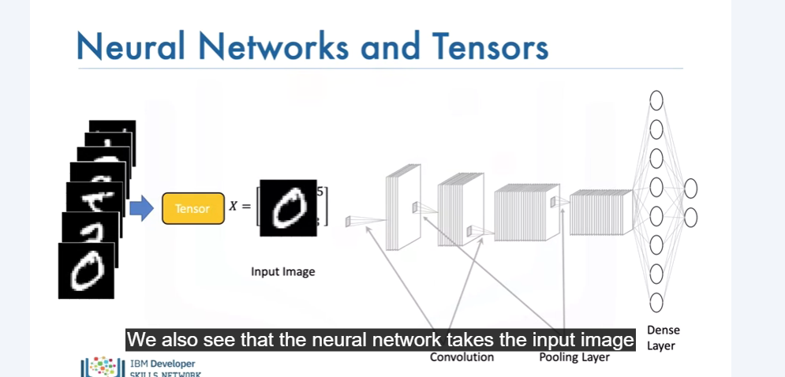
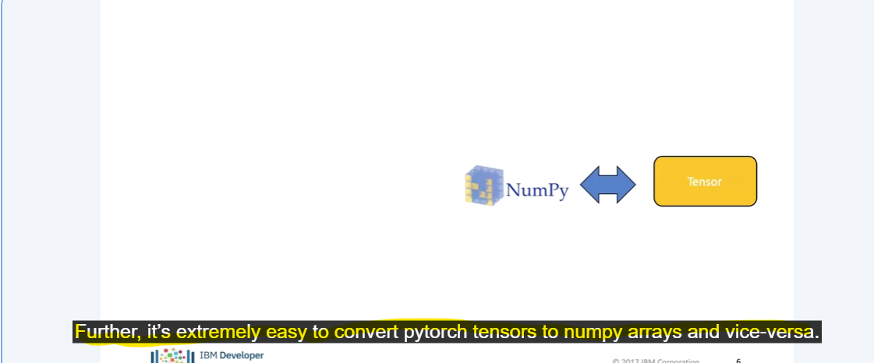
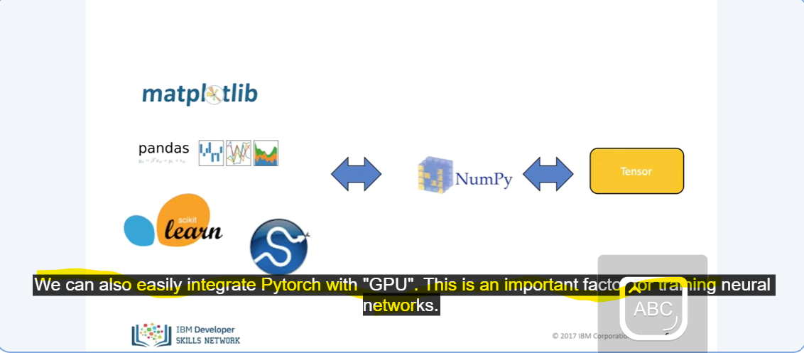
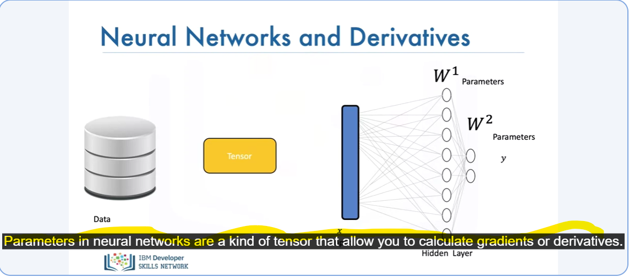
Gradients and derivatives will allow you to train the neural network

